GUTS Data Acquired at GGAO
The following pages present data analysis results based on data acquired by the GUTS system while at GGAO. The analysis is somewhat abbreviated due to the accelerated delivery schedule. No formal ground tests were taken, and only 3 Lageos 1 and Lageos 2 passes were collocated. While the GUTS system acquired its first pass, a small Starlette pass, on September 17, 2003, system development continued to impact system performance for the next several months. System performance became relatively stable on the later part of December 2, 2003.
Three sections follow, starting with ground data, then satellite data, and finally collocated data.

Ground Data
The GUTS system acquired 67 ground target data sets since December 2, 2003, primarily to calibrate satellite passes. No formal ground tests were performed due to the accelerated delivery schedule. Eight of the data sets were taken in geosynchronous mode. The delays are two-way delays, so the apparent range error between targets 5009991 and 509992 would be (56.4158-56.4081)/2, or 3.85mm.

Ground Targets Used Since December 2, 2003
Target Name | Target ID | No. of Data Sets | Mean Delay  (meters)
Target-B | 5009991 | 7 | 56.4158
Target-C | 5009992 | 43 | 56.4081  (5 sets edited)
Target-B Geosynchronous | 5009981 | 6 | 35.6250
Target-C Geosynchronous | 5009982 | 1 | 35.6303
Internal Cal | 5009901 | 9 | 56.1902
Internal Cal Geosynchronous | 5009902 | 1 | 35.6531

Ground Target Data Sets Acquired Since December 2, 2003
Date Time (GMT) | Observations | RMS (meters) | Delay (meters)
5009991 – Ground Target B
2003-12-02 03:33:11 | 1084 | 0.001601 | 56.415386
2003-12-02 05:05:51 | 1075 | 0.001494 | 56.413501
2003-12-02 06:05:30 | 1731 | 0.001293 | 56.411957
2003-12-02 07:09:48 | 962 | 0.001465 | 56.417484
2003-12-30 23:30:38 | 1034 | 0.001655 | 56.415602
2003-12-31 00:59:18 | 1057 | 0.001651 | 56.418068
2003-12-31 01:25:51 | 1266 | 0.001596 | 56.41829
5009992 – Ground Target C
2003-12-02 03:30:11 | 1120 | 0.001421 | 56.416708
2003-12-02 05:08:48 | 1022 | 0.001429 | 56.413718
2003-12-02 05:44:14 | 61 | 0.001538 | 56.415633
2003-12-02 05:49:12 | 766 | 0.001449 | 56.412864
2003-12-02 05:54:31 | 872 | 0.001336 | 56.412055
2003-12-02 21:39:50 | 1357 | 0.001704 | 56.429154
2003-12-02 23:46:07 | 996 | 0.001561 | 56.412109
2003-12-03 00:41:12 | 927 | 0.001286 | 56.415772
2003-12-03 01:11:20 | 1058 | 0.001596 | 56.415247
2003-12-03 02:14:11 | 895 | 0.001387 | 56.413785
2003-12-03 05:12:05 | 1216 | 0.001547 | 56.415762
2003-12-07 22:41:14 | 1012 | 0.001633 | 56.416104
2003-12-07 23:30:04 | 1055 | 0.00159 | 56.414744
2003-12-08 00:39:54 | 771 | 0.001573 | 56.417432
2003-12-08 01:21:15 | 112 | 0.003667 | 57.088516
2003-12-08 01:22:16 | 938 | 0.003661 | 57.090545
2003-12-08 16:03:49 | 5859 | 0.003553 | 57.07439
2003-12-08 16:31:46 | 1021 | 0.003625 | 57.073768
2003-12-11 22:49:02 | 6411 | 314122.967 | 4289629.034
2003-12-11 23:01:49 | 1107 | 0.002206 | 56.419803
2003-12-12 00:40:40 | 1533 | 0.001556 | 56.414234
2003-12-12 02:13:32 | 979 | 0.001438 | 56.407468
2003-12-12 03:13:05 | 975 | 0.00149 | 56.407843
2003-12-12 04:13:46 | 1288 | 0.001563 | 56.412802
2003-12-12 05:37:44 | 1120 | 0.001585 | 56.412137
2003-12-15 22:25:04 | 2096 | 0.001556 | 56.410396
2003-12-16 00:10:15 | 1543 | 0.001675 | 56.410537
2003-12-16 00:47:48 | 2724 | 0.001694 | 56.409445
2003-12-16 01:41:20 | 1112 | 0.001739 | 56.408664
2003-12-16 03:39:04 | 1014 | 0.00174 | 56.419071
2003-12-31 22:13:22 | 1599 | 0.001496 | 56.43146
2003-12-31 22:34:11 | 1088 | 0.001419 | 56.431943
2004-01-07 22:50:33 | 1062 | 0.002237 | 56.387347
2004-01-07 23:24:38 | 1036 | 0.001417 | 56.388516
2004-01-08 00:06:03 | 1061 | 0.001394 | 56.388086
2004-01-08 01:13:40 | 1034 | 0.001486 | 56.390165
2004-01-08 02:23:30 | 1092 | 0.001572 | 56.391487
2004-01-09 23:32:18 | 164 | 0.0013 | 56.388722
2004-01-09 23:33:24 | 809 | 0.001316 | 56.388352
2004-01-10 00:56:42 | 1196 | 0.00154 | 56.398319
2004-01-10 01:28:57 | 1026 | 0.001384 | 56.395097
2004-01-10 23:15:19 | 1166 | 0.00139 | 56.386039
2004-01-11 00:39:03 | 946 | 0.00142 | 56.387387
5009982 – Ground Target C Geosynchronous
2003-12-03 01:58:43 | 245 | 0.014176 | 35.622757
2003-12-31 21:28:51 | 320 | 0.01416 | 35.64273
2003-12-31 22:09:43 | 202 | 0.014619 | 35.642154
2004-01-10 00:14:57 | 462 | 0.012241 | 35.624634
2004-01-10 00:29:46 | 482 | 0.012691 | 35.622044
2004-01-10 00:52:58 | 105 | 0.015537 | 35.627681
5009981 – Ground Target B Geosynchronous
2003-12-31 01:31:27 | 136 | 0.012775 | 35.624965
5009901 – Internal Calibration Target
2003-12-02 06:01:31 | 1572 | 0.002328 | 57.234901
2003-12-02 07:18:24 | 945 | 0.003862 | 56.886064
2003-12-02 07:24:26 | 367 | 0.003795 | 56.42211
2003-12-02 07:30:10 | 2598 | 0.230652 | 56.203949
2003-12-02 07:35:51 | 1978 | 0.008363 | 56.443646
2003-12-02 07:40:05 | 553 | 0.009768 | 56.41532
2003-12-03 01:17:08 | 90 | 0.00901 | 55.235178
2003-12-03 01:17:30 | 776 | 0.382815 | 55.633268
2003-12-03 01:19:11 | 801 | 0.00652 | 55.237451
5009902 – Internal Calibration Target Geosynchronous
2003-12-03 02:10:51 | 664 | 0.01282 | 35.653103

Satellite Data
The GUTS system acquired a total of 88 satellite passes while tracking from GGAO. 19 different satellites were tracked from September 17, 2003 through January 11, 2004. Data quality markedly improved on the night of December 2, 2003, after some troubleshooting and corrections. The system acquired 57 passes after that time.

Satellites Tracked at GGAO
Name | SIC | COSPAR | Number of Passes | After 12/02/2003
Ajisai | 1500 | 8606101 | 10 | 4
BEC | 317 | 6503201 | 6 | 6
Champ | 8002 | 0003902 | 2 | 2
Envisat-1 | 6179 | 0200901 | 5 | 4
ERS-2 | 6178 | 9502101 | 4 | 3
Etalon-1 | 525 | 8900103 | 3 | 3
Etalon-2 | 4146 | 8903903 | 1 | 0
GFO-1 | 8501 | 9800701 | 3 | 1
Glonass-84 | 9084 | 0006302 | 2 | 0
Glonass-87 | 9087 | 0105302 | 2 | 0
Glonass-89 | 9089 | 0206001 | 4 | 4
GPS-35 | 3535 | 9305401 | 2 | 2
Jason | 4378 | 0105501 | 7 | 6
Lageos-1 | 1155 | 7603901 | 5 | 4
Lageos-2 | 5986 | 9207002 | 8 | 6
Larets | 5557 | 0304206 | 3 | 2
Starlette | 1134 | 7501001 | 7 | 0
Stella | 643 | 9306102 | 4 | 4
Topex | 4377 | 9205201 | 10 | 6

The following table displays some SPAS processing results retrieved from the MySQL database. A ‘G’ following the Date of Data indicates that the pass was acquired in geosynchronous mode.
Passes Acquired After December 2, 2003
Date of Data (GMT) | Number of Observations | Number of Normal Points | IRV Fit RMS  (meters) | High Order Polynomial RMS (meters)
Ajisai (1500)
2003-12-03 00:50:12 | 5169 | 23 | 0.011292 | 0.011339
2003-12-08 00:23:00 | 6643 | 27 | 0.01119 | 0.020668
2003-12-11 22:49:02 | 5916 | 24 | 0.011018 | 0.011731
2003-12-16 01:20:03 | 975 | 13 | 0.013975 | 0.013795
BEC (317)
2003-12-03 01:01:50 | 3275 | 35 | 0.006432 | 0.014763
2003-12-03 02:54:38 | 3482 | 36 | 0.006734 | 0.04241
2003-12-07 23:15:54 | 3388 | 28 | 0.007627 | 0.008133
2003-12-08 01:09:22 | 4527 | 41 | 0.006792 | 0.182631
2003-12-12 02:06:26 | 2595 | 20 | 0.005145 | 0.005132
2003-12-16 01:01:04 | 2531 | 27 | 0.009176 | 0.146011
Champ (8002)
2003-12-03 02:42:30 | 104 | 0 | 0.002192 | 0.002306
2004-01-08 00:20:02 | 627 | 0 | 0.002367 | 0.002423
Envisat-1 (6179)
2003-12-03 02:18:00 | 261 | 6 | 0.00336 | 0.003389
2003-12-12 02:35:58 | 2062 | 21 | 0.002911 | 0.003553
2004-01-08 01:47:28 | 2009 | 22 | 0.002929 | 0.002942
2004-01-11 01:52:58 | 2737 | 23 | 0.002709 | 0.002718
ERS-2 (6178)
2003-12-03 02:45:48 | 1620 | 20 | 0.003803 | 0.020042
2003-12-12 03:03:06 | 2918 | 21 | 0.003316 | 0.042852
2004-01-08 02:16:12 | 1614 | 19 | 0.003158 | 0.003187
Etalon-1 (525)
2003-12-07 22:45:47 | 115 | 2 | 0.01272 | 0.012816
2003-12-07 23:11:17 | 67 | 1 | 0.013535 | 0.013535
2004-01-07 23:03:53 | 212 | 5 | 0.014695 | 0.013891
GFO-1 (8501)
2003-12-12 03:58:48 | 3007 | 23 | 0.003016 | 0.06234
Glonass-89 (9089)
2003-12-02 23:53:19 | 112 | 2 | 0.010911 | 0.010822
2003-12-03 01:29:58 | 290 | 2 | 0.006274 | 0.005868
2003-12-03 01:37:42 | 52 | 2 | 0.017935 | 0.02041
2004-01-11 00:43:11 | 1215 | 7 | 0.009593 | 0.009476
GPS-35 (3535)
2003-12-03 01:48:58 G | 903 | 3 | 0.017576 | 0.017715
2004-01-09 23:37:25 | 2846 | 3 | 0.016782 | 0.01677
Jason (4378)
2003-12-02 22:03:42 | 835 | 13 | 0.003339 | 0.003329
2003-12-03 00:00:21 | 1310 | 21 | 0.003026 | 0.003007
2003-12-31 01:05:43 | 2015 | 25 | 0.00409 | 0.004088
2004-01-08 00:13:51 | 1788 | 21 | 0.003063 | 0.003047
2004-01-10 01:00:38 | 2231 | 36 | 0.003321 | 0.003309
2004-01-11 01:24:16 | 468 | 20 | 0.003402 | 0.003409
Lageos-1 (1155)
2003-12-03 03:07:11 | 1404 | 3 | 0.005676 | 0.005606
2003-12-03 03:11:47 | 7541 | 13 | 0.005621 | 0.005599
2003-12-12 04:49:42 | 13133 | 24 | 0.005522 | 0.005724
2003-12-16 02:54:23 | 3604 | 22 | 0.007149 | 0.006989
Lageos-2 (5986)
2003-12-03 04:26:23 | 10584 | 23 | 0.005996 | 0.006082
2003-12-12 03:28:31 | 5216 | 14 | 0.006204 | 0.006123
2003-12-12 04:08:13 | 207 | 2 | 0.005459 | 0.005335
2004-01-08 00:35:36 | 7150 | 19 | 0.005979 | 0.005977
2004-01-08 13:00:49 | 667 | 6 | 0.006899 | 0.006836
2004-01-10 01:19:13 | 1528 | 5 | 0.006268 | 0.006179
Larets (5557)
2003-12-03 04:19:38 | 264 | 5 | 0.003157 | 0.003169
2003-12-12 03:20:19 | 2698 | 25 | 0.003251 | 0.038523
Stella (643)
2003-12-02 21:52:30 | 747 | 8 | 0.003362 | 0.003286
2003-12-07 22:58:06 | 1862 | 20 | 0.004412 | 0.006042
2003-12-31 22:24:30 | 2170 | 22 | 0.00396 | 0.003966
2004-01-07 22:38:21 | 2504 | 25 | 0.013507 | 0.056648
Topex (4377)
2003-12-02 22:09:10 | 3941 | 38 | 0.01303 | 0.019016
2003-12-03 00:07:20 | 3194 | 28 | 0.010316 | 0.01027
2003-12-31 01:13:08 | 4848 | 40 | 0.013549 | 0.013631
2004-01-08 00:22:37 | 4974 | 42 | 0.012703 | 0.016186
2004-01-10 01:10:09 | 2786 | 26 | 0.008635 | 0.010074
2004-01-11 01:31:47 | 1768 | 16 | 0.007269 | 0.007184

The GUTS system generated 131 normal points on Lageos 1 and Lageos 2 in 10 passes tracked during the period following December 2, 2003. The mean normal point rms across all 131 normal points (with 1 edited) was 0.51mm. The following table provides the mean normal point rms on a pass by pass basis.
Lageos Pass Normal Point RMS
Date of Data (GMT) | Number of Normal Points | Mean Normal Point RMS (mm)
Lageos–1 (1155)
2003-12-03 03:07:11 | 3 | 0.48
2003-12-03 03:11:47 | 13 | 0.28
2003-12-12 04:49:42 | 24 | 0.30
2003-12-16 02:54:23 | 22 | 1.10
Lageos-2 (5986)
2003-12-03 04:26:23 | 23 | 0.31
2003-12-12 03:28:31 | 14 | 0.50
2003-12-12 04:08:13 | 2 | 0.88
2004-01-08 00:35:36 | 19 | 0.37
2004-01-08 13:00:49 | 6 | 0.98
2004-01-10 01:19:13 | 5 | 0.40

The following few pages display screen shots of a selection of SPAS plots for Ajisai, Lageos 1, Lageos 2, and Topex passes. The Topex pass is included mainly to show the receive energy dependency curve across the full range of receive energies. Also included is a return rate plot for a GPS-35 pass acquired in geosynchronous mode.
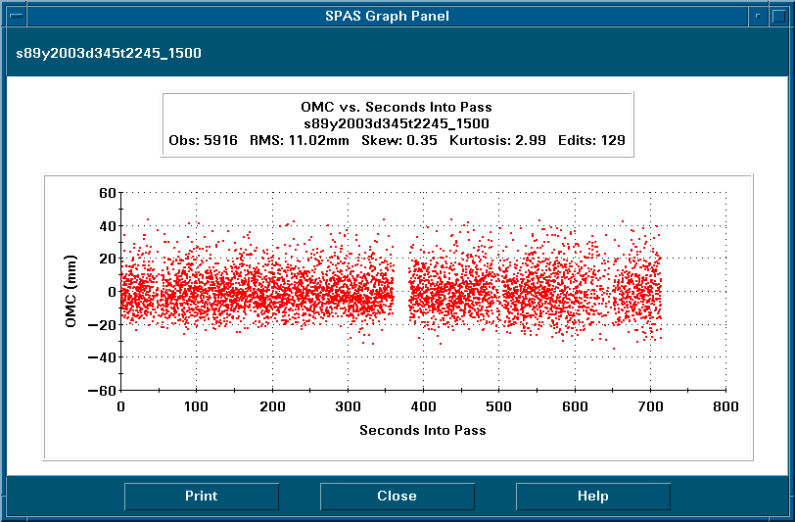
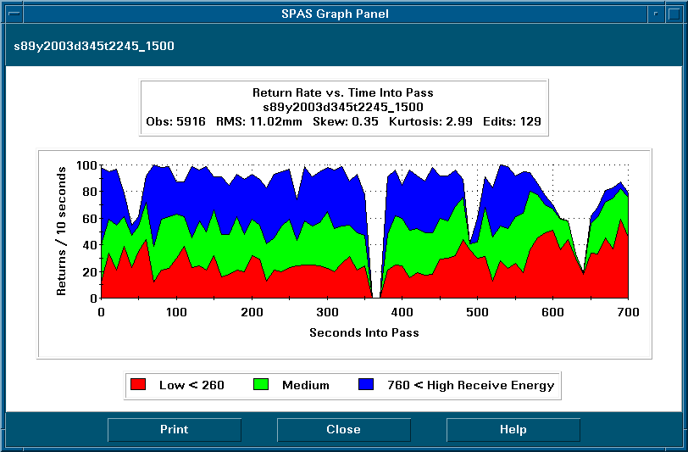
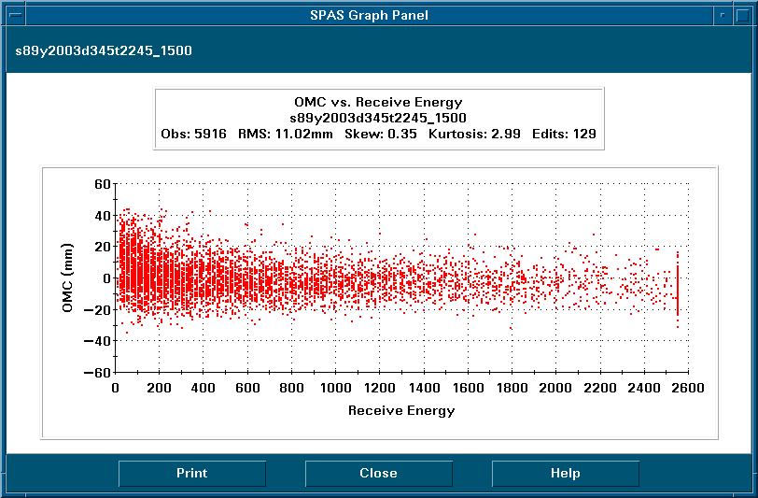
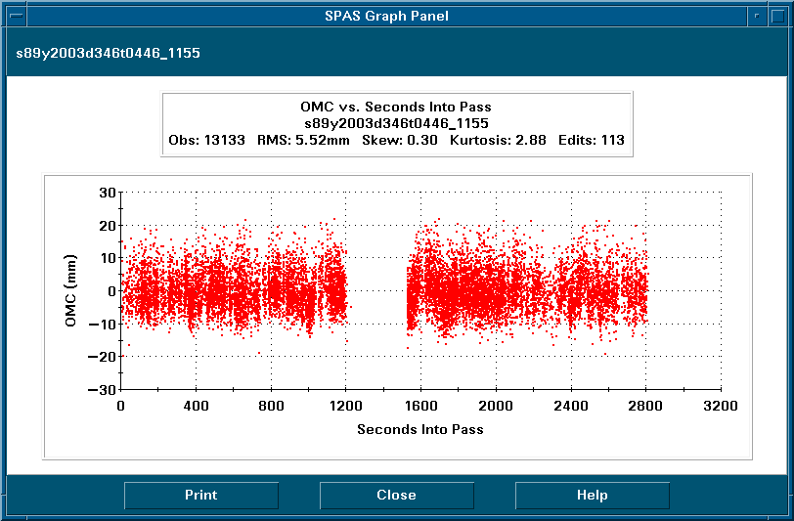
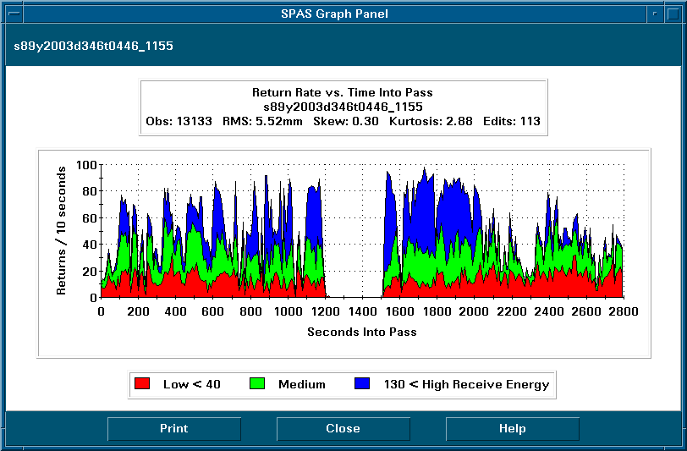
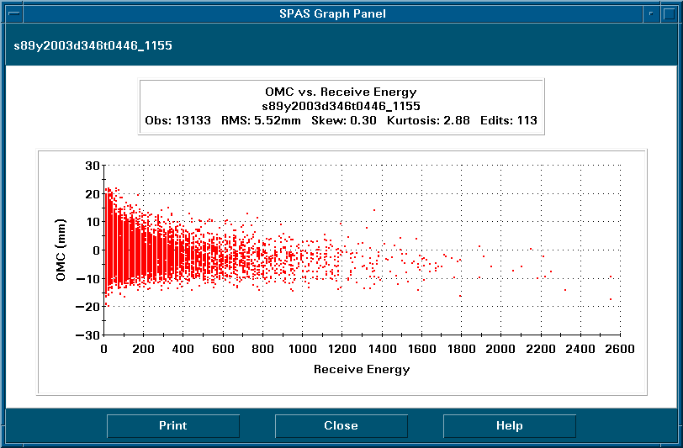
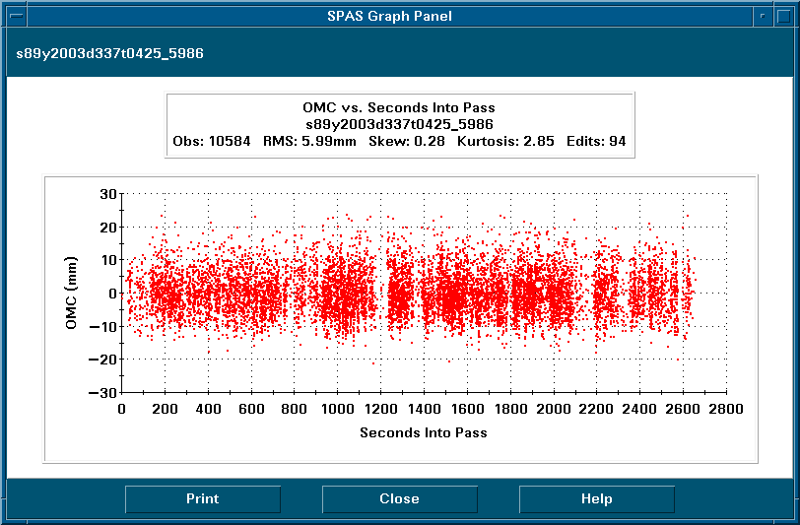
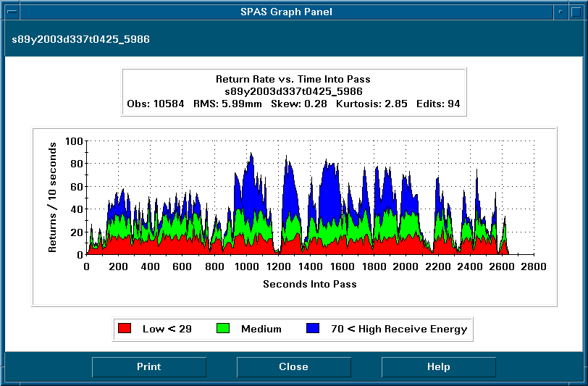
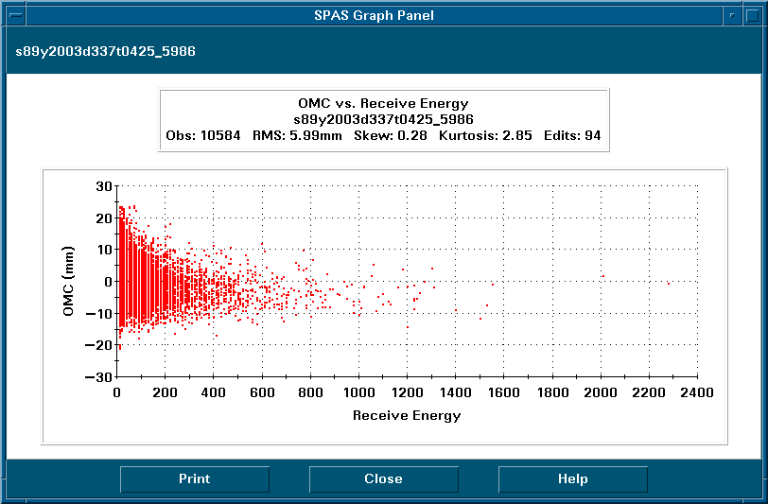
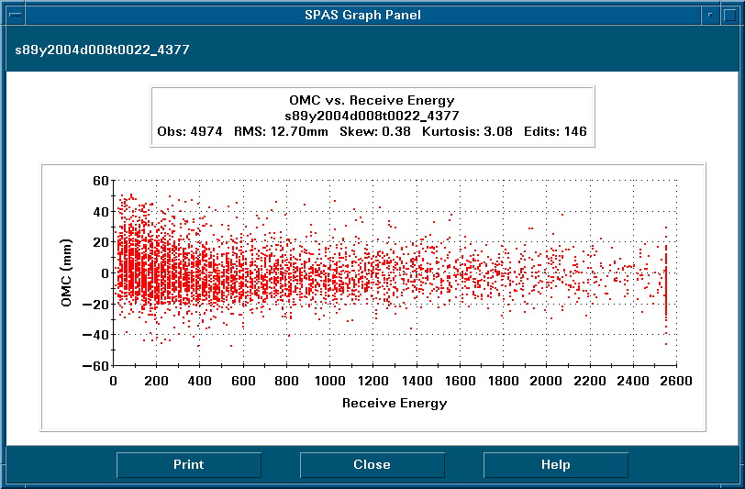
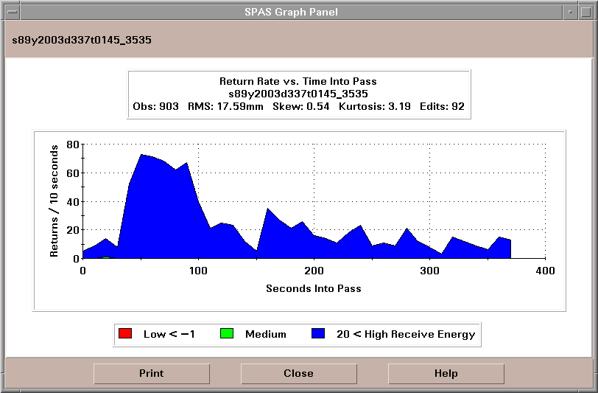

Collocated Data
While at GGAO, the GUTS system collocated 25 passes with MOBLAS 7 on 12 different satellites. The following plots were generated by Polyquick and compare GUTS (Test) data with data from the reference (Base) station, MOBLAS 7.

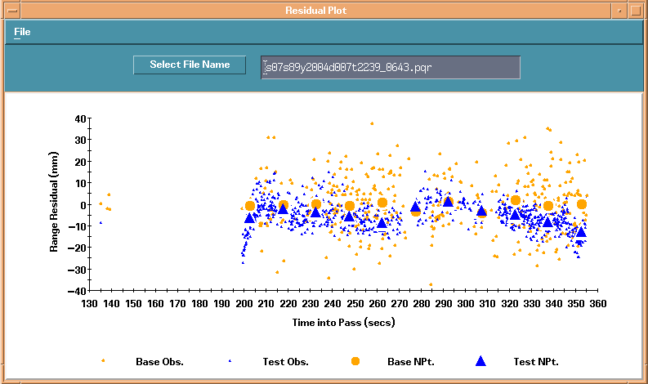
Stella 2004-01-07 22:38:21
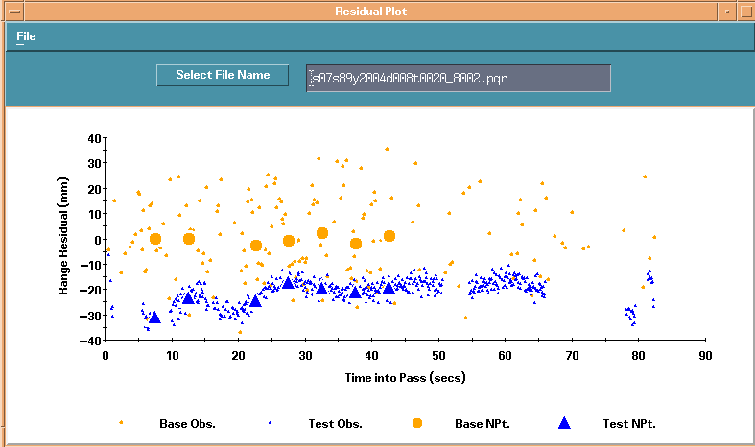
Champ 2004-01-08 00:20:02
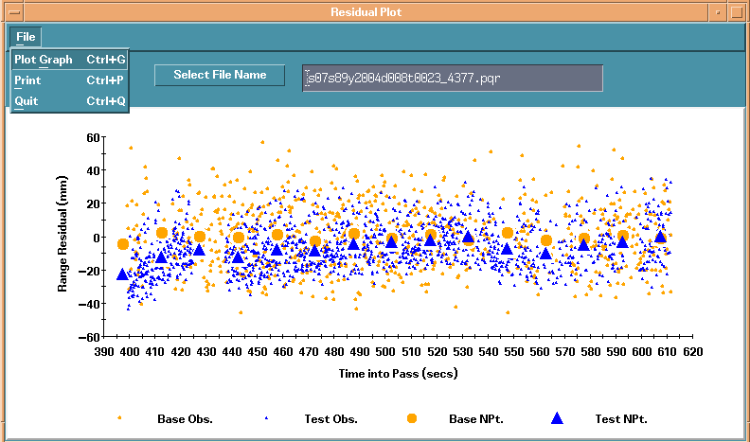
Topex 2004-01-08 00:22:37
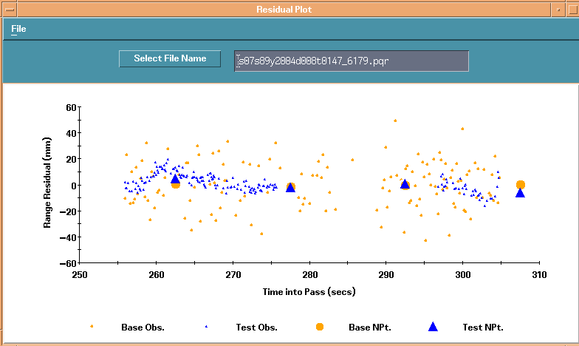
Envisat-1 2004-01-08 01:47:28
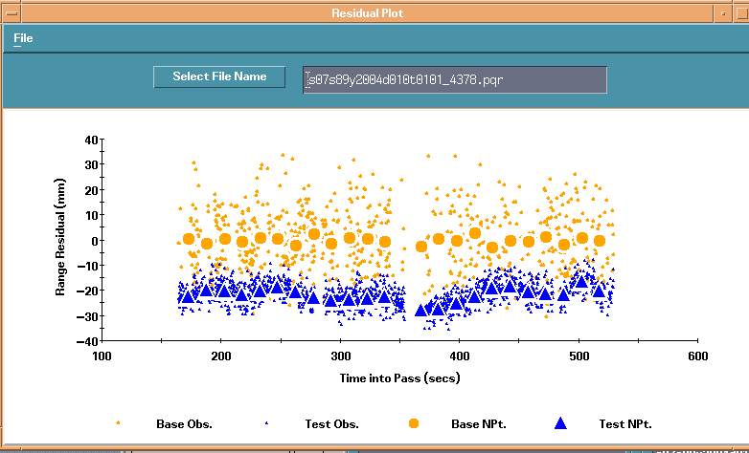
Jason 2004-01-10 01:00:38
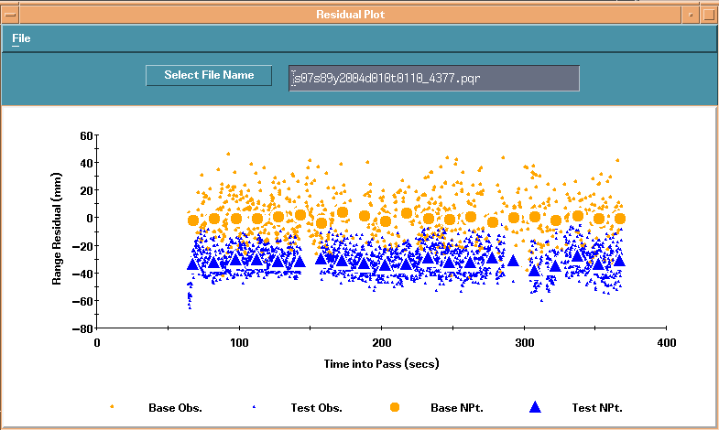
Topex 2004-01-10 01:10:09
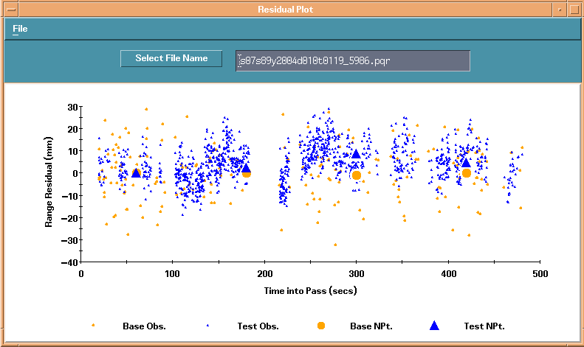
Lageos 2 2004-01-10 01:19:13
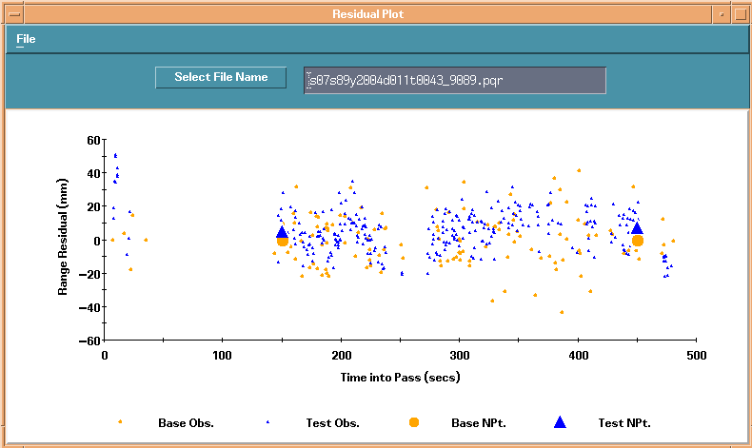
Glonass 89 2004-01-11 00:43:11
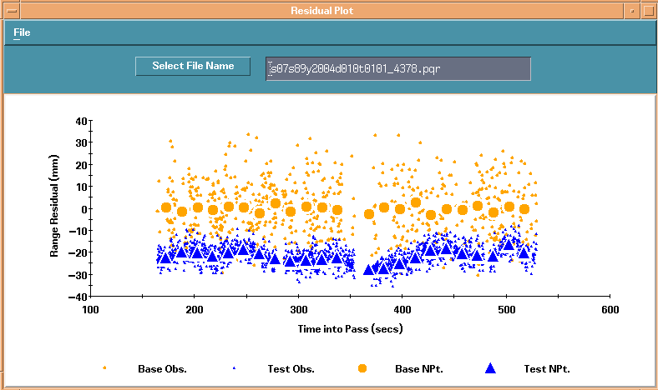
Jason 2004-01-10 01:00:38
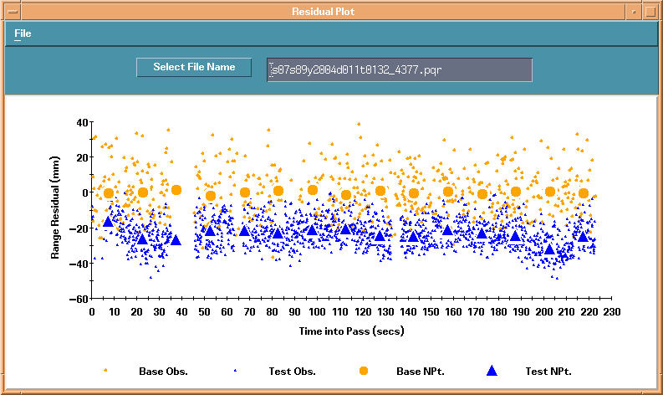
Topex 2004-01-11 01:31:47
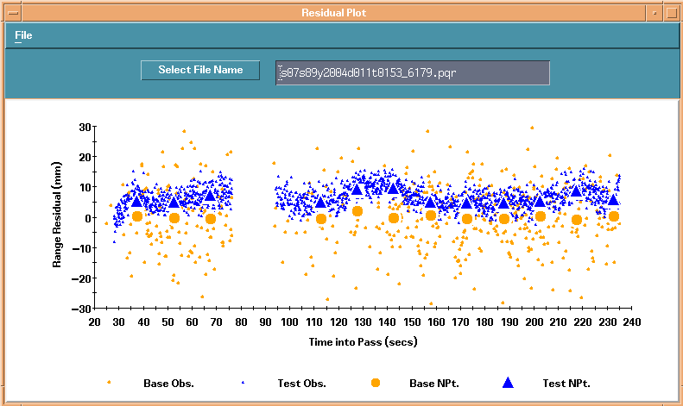
Envisat-1 2004-01-11 01:52:58

The following table lists the Polyquick results for the collocated passes. In the table, the WTD Mean column gives the difference between the systems, GUTS minus MOBLAS 7. MOBLAS 7 suffered a hardware failure during the last half of December.

Polyquick Results for Collocated Passes
COSPAR | Date | Time (GMT) | Bins | GUTS Dly | M7 Dly | M7 Obs | GUTS Obs | GUTS RMS | M7 RMS | WTD Mean | Peak Peak | Diff. Temp | Dif H | WTD Press | GTS SFT | M7 SFT
 |  | hhmm |  |  |  |  |  | mm | mm | mm | mm | C | % | mlb | mm | mm
9800701 | 11/18/03 | 124 | 11 | 33304.84 | 14597.49 | 773 | 866 | 6.2 | 7.4 | 3.4 | 10.7 | 1 | 1 | 0.2 | 0 | 0.9
7501001 | 11/18/03 | 136 | 11 | 33304.84 | 14597.49 | 966 | 1705 | 11.9 | 11.1 | 5.2 | 32.8 | 1.6 | 1 | 0.2 | 0 | 0.9
105501 | 11/18/03 | 202 | 6 | 33304.84 | 14597.49 | 1557 | 413 | 346.7 | 71.1 | -0.9 | 4.7 | 0.7 | 0 | 0.1 | 0 | 0.9
9306102 | 12/2/03 | 2148 | 3 | 28214.52 | 14597.34 | 806 | 732 | 3.5 | 7.3 | -4 | 2.1 | 0.2 | 7 | 0.1 | 0 | 3.3
105501 | 12/2/03 | 2356 | 15 | 28206.12 | 14597.34 | 1322 | 1042 | 3.5 | 6.9 | -3.7 | 7 | 0.2 | 7 | 0.3 | 0 | 1.95
6503201 | 12/3/03 | 58 | 13 | 28207.62 | 14597.34 | 1348 | 3156 | 1077.8 | 666.8 | -29.3 | 518.5 | 0.1 | 6 | 0.1 | 0 | 1.95
9205201 | 12/3/03 | 6 | 14 | 28206.12 | 14597.34 | 1055 | 2555 | 33.9 | 27.7 | -14 | 14.3 | 0.1 | 7 | 0.2 | 0 | 1.95
8606101 | 12/3/03 | 48 | 17 | 28207.92 | 14597.34 | 1631 | 3595 | 14.4 | 15.3 | -13.4 | 18.6 | 0.1 | 7 | 0.2 | 0 | 1.95
9207002 | 12/3/03 | 426 | 3 | 28207.92 | 14601.54 | 84 | 625 | 6.8 | 8.7 | -2.2 | 2.5 | 1.6 | 9 | 0.2 | 0 | 0
9306102 | 12/7/03 | 2256 | 8 | 28207.77 | 14600.19 | 1170 | 1260 | 631.1 | 608.9 | -12 | 607.7 | 0.5 | 11 | 0.2 | 0.75 | -1.35
8606101 | 12/8/03 | 20 | 2 | 28208.52 | 14599.74 | 337 | 291 | 10.9 | 14.1 | -3.2 | 0.3 | 1.3 | 12 | 0.2 | 1.35 | 2.25
6503201 | 12/8/03 | 108 | 34 | 28208.67 | 14600.49 | 1993 | 4471 | 614 | 575.3 | -12.3 | 397.5 | 2.9 | 7 | 0.2 | 0 | -0.45
7603901 | 12/16/03 | 254 | 1 | 28208.52 | 14592.85 | 60 | 15 | 5.9 | 13.8 | 2.2 | 0 | 2.6 | 3 | 0.1 | 5.25 | 4.95
8606101 | 12/16/03 | 118 | 12 | 28204.47 | 14589.25 | 1195 | 964 | 14.4 | 17.5 | -8 | 11.7 | 0.1 | 5 | 0.2 | 0.45 | 4.8
9306102 | 1/7/04 | 2239 | 11 | 28193.7 | 14590 | 381 | 780 | 6.4 | 12.8 | -5.5 | 15.7 | 7 | 9 | 0.25 | 0 | 1.95
3902 | 1/8/04 | 20 | 7 | 28194.3 | 14593.3 | 123 | 288 | 4.8 | 15.3 | -20.9 | 14.6 | 7.8 | 9 | 0.2 | 0.3 | 1.05
9205201 | 1/8/04 | 23 | 15 | 28194.3 | 14593.3 | 783 | 1426 | 13.2 | 19.2 | -6.9 | 20.7 | 7.7 | 9 | 0.23 | 0.3 | 1.5
200901 | 1/8/04 | 147 | 4 | 28195.5 | 14594.8 | 139 | 166 | 6.6 | 18 | 1.7 | 10.5 | 8.6 | 9 | 0.2 | 0.6 | 4.8
105501 | 1/10/04 | 101 | 23 | 28198.8 | 14579.5 | 699 | 1719 | 4.2 | 11.9 | -21.8 | 11.2 | 11.8 | 7 | 0.14 | 1.65 | 8.5
9205201 | 1/10/04 | 110 | 21 | 28198.3 | 14579.5 | 828 | 2190 | 9 | 15.9 | -31.7 | 13.5 | 12 | 7 | 0.1 | 1.65 | 8.5
9207002 | 1/10/04 | 119 | 4 | 28197.9 | 14579.5 | 194 | 1218 | 7.8 | 12.3 | 4.5 | 9.6 | 12.5 | 8 | 0.17 | 1.65 | 8.5
206001 | 1/11/04 | 43 | 2 | 28193.7 | 23798.3 | 132 | 298 | 12.3 | 15.3 | 5.8 | 2.4 | 20 | 6 | 0.1 | 0 | -4.05
105501 | 1/11/04 | 124 | 6 | 28193.7 | 14577.3 | 82 | 227 | 4.1 | 9.5 | -20 | 4.6 | 24 | 8 | 0.1 | 0 | 1.05
9205201 | 1/11/04 | 132 | 5 | 28193.7 | 14577.3 | 621 | 1637 | 8 | 13.2 | -23.6 | 16.7 | 23.9 | 14 | 0.1 | 0 | 1.05
200901 | 1/11/04 | 153 | 12 | 28193.7 | 14577.3 | 499 | 1528 | 3.4 | 10.3 | 6.3 | 5.1 | 23.5 | 17 | 0.2 | 0 | 1.05

